Please download zip files to answer problems

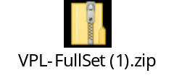
https://virtualphysicslabs.ket.org/?_ga=2.39118371.1280591333.1546635258-825398634.1528935324
log in is : NT713851@GMAIL.COM
password: William28
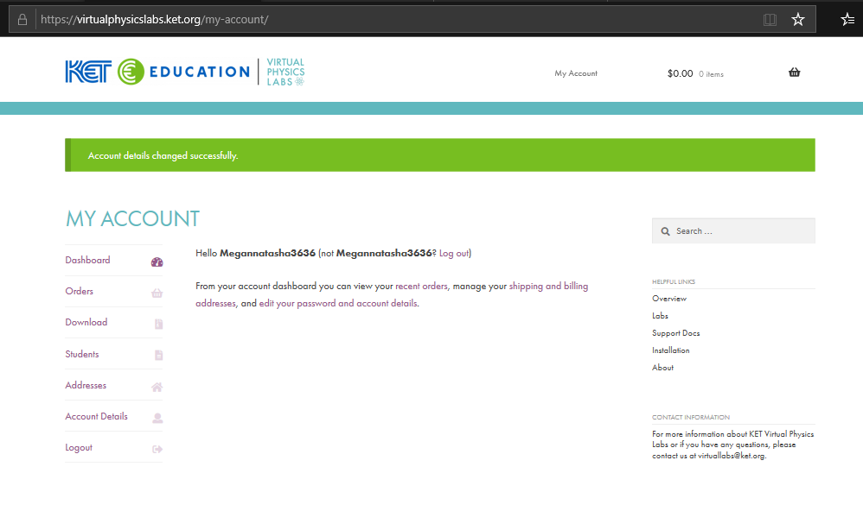
Assignment 1
- Go to the KET website and go to the 'support docs' section.
- Scroll down to find the User's Guide heading and download/view the User Guide for the Dynamics Track, if needed. (This needs to be done before starting the lab!)
- Scroll up the page to the Lab Activities heading and find/download the Pulleys, Ramps, and Friction lab - student version, a pdf file.
- Review the lab to get a basic understanding of what will occur during the lab, review basic concepts from text, if needed. (Do only Parts 1 & 2 of the lab along with the prelab section.)
- When ready, open/run the Dynamics Track sim from the downloaded lab bundle also be ready to open/run the Grapher sim; as you will be using it during the lab (It will likely take several hours to work through the lab so schedule your time appropriately.)
- Print the Forces Lab Report (Force Lab Report.pdf ) and as you work through the lab, list your answers, and any required work, on Lab Report by hand. Making sure to answer any pre-lab questions and question at the end of the lab report. This is what you will eventually submit. You need to scan or take picture of your lab report and convert it to PDF file and then submit it.
- When completed with the lab, close it and exit out.
- When completed, submit your Lab Report as a PDF file attachment to the lab assignment before the due date. 6/6/2020
SEE ATTATCHMENT

Please download zip files to answer problems

Assignment 2

Scroll down to find the User's Guide heading and download/view the User Guide for the Circular Motion app. (This needs to be done before starting the lab!)
3. Scroll up the page to the Lab Activities heading and find/download the Circular Motion lab - student version, a pdf file.
4. Review the lab to get a basic understanding of what will occur during the lab, review basic concepts from text, if needed. (Do all parts of the lab.)
5. When ready, open/run the Circular Motion lab by clicking on the link at the top of the page, also be ready to open/run the Grapher app., as you will be using it during the lab. (It will likely take several hours to work through the lab so schedule your time appropriately.)
6. Print the Circular Motion Lab Report (Circular_motion Lab Report.pdf) and as you work through the lab, list your answers, and any required work, on the Lab Report by hand. Making sure to answer any pre-lab questions and question at the end of the lab report. This is what you will eventually submit. You need to scan or take picture of your lab report and convert it to PDF file and then submit it.
7. When completed with the lab, close it and exit out.
- 8. When completed, submit your Lab Report as a PDF file attachment to the lab assignment before the due date. 6/8/2020
SEE ATTATCHMENT

